

GoWarrior FTool

V1.0

User Manual

**Copyright Statement**

ALi Corporation makes no representations or warranties with respect to the accuracy or completeness of the contents of this document. No license, whether express, implied, arising by estoppel or otherwise, to any intellectual property right is granted by this document.

ALi Corporation also reserves the right to make changes to these specifications and product description at any time without notice.

Contact your local sales office to obtain the latest specifications before placing your order.

Third-party brands and names mentioned in this publication are for identification purpose only and may be the property of their respective owners.

Microsoft®, and Windows® are registered trademarks of Microsoft Corporation in the United States and other countries.

Linux® is a registered trademark of Linus Torvalds.

Supply of this Implementation of Microsoft Corporation and Linus Torvalds does not convey a license nor imply a right under any patent, or any other industrial or intellectual property right of Microsoft Corporation and Linus Torvalds, to use this Implementation in any finished end-user or ready-to-use final product. It is hereby notified that a license for such use is required from Microsoft Corporation and Linus Torvalds.

**Copyright © 2015 ALi Corporation. All rights reserved.**

Table of Contents

Preface 1

Overview 1

Audience 1

Application Products 1

Conventions 2

Acknowledgement 3

1 Environment Preparation 4

2 Flash Burning 6

2.1 Connecting to Platform 6

2.2 Opening Profile 8

2.3 Selecting Partitions to Burn 9

2.4 Starting Burning 11

2.5 Finishing Burning 11

3 Making A Burning File Package 13

4 Flash Dumping 15

4.1 Connecting to Platform 15

4.2 Opening Profile 15

4.3 Selecting Items to Dump 15

4.4 Starting Dumping 16

4.5 Finishing Dumping 17

5 Modifying MAC Address of Platform 18

5.1 Connecting to Platform 18

5.2 Opening Profile 18

5.3 Modifying MAC Address 18

6 Partition Burn Check 20

Revision History 21

List of Tables

Table 1. Typographical Conventions 2

Table 2. Symbol Conventions 2

Table 3. Revision History 23

List of Figures

Figure 1. Partition Information 5

Figure 2. Sample Cable and Adapter 6

Figure 3. Sample Demo Board 6

Figure 4. Connect Platform to PC via USB Cable 7

Figure 5. Upgrade Button 7

Figure 6. Connect to Platform 8

Figure 7. Open Profile 9

Figure 8. Partition Options 10

Figure 9. Select Partitions to Burn 11

Figure 10. Start Burning Flash 12

Figure 11. Burning Completed 13

Figure 12. Archive Name and Parameters 15

Figure 13. Select Items to Dump 17

Figure 14. Start Dumping 18

Figure 15. Dumping Completed 19

Figure 16. Edit MAC Address 21

Figure 17. Partition Burn Check 22

Preface

Overview

This guide mainly introduces how to use FTool tool to burn NAND Flash of ALi platform. It is organized by the following chapters:

* **Chapter 1: Environment Preparation**

This chapter introduces the environment required by the FTool.

* **Chapter 2: Flash Burning**

This chapter introduces how to burn NAND Flash by using FTool.

* **Chapter 3: Making A Burning File Package**

This chapter introduces how to make a burning file package.

* **Chapter 4: Flash Dumping**

This chapter introduces how to dump data from NAND Flash.

* **Chapter 5: Modifying MAC Address in Platform**

This chapter introduces how to modify the MAC address of the partition file parsed by FTool.

* **Chapter 6: Partition Burn Check**

This chapter introduces how FTool reads data back from NAND Flash and checks them against original data.

Audience

This manual is mainly applicable for the following engineers.

* Test engineers
* Software development engineers
* FAE (Field application engineers)

Application Products

The manual is applicable for ALi platforms supporting NAND Flash.

Conventions

**Typographical Conventions**

| Item | Format |
| --- | --- |
| codes, keyboard input commands, file names, equations**,**and math | Courier New, Size 10.5 |
| *Variables, code variables*,and *code comments* | *Courier New, Size, Italic* |
| **Menu item, buttons, tool names** | **Times New Roman, Size 10.5, Bold**  e.g. Select **USB Debugging** |
| **Screens**, windows, **dialog boxes,** and **tabs** | **Times New Roman, Size 10.5, Bold**  **Enclosed in double quotation marks**  e.g. Open the **“Debug Configuration”** dialog box |

Table . Typographical Conventions

**Symbol Conventions**

| Item | Description |
| --- | --- |
| ***Caution*** | Indicates a potential hazard or unsafe practice that, if not avoided, could result in data loss, device performance degradation, or other unpredictable results. |
| ***C:\Users\Icy.Liu\Pictures\icons\note.pngNote*** | Indicates additional and supplemental information for the main contents. |
| ***C:\Users\Icy.Liu\Pictures\icons\tip.pngTip*** | Indicates a suggestion that may help you solve a problem or save your time. |

Table . Symbol Conventions

Acknowledgement

**Microsoft®**, and **Windows®** are registered trademarks of Microsoft Corporation in the United States and other countries.

**Linux®** is a registered trademark of Linus Torvalds.



# Environment Preparation

FTool is a software tool that runs on Windows operating system. It is used to burn the NAND Flash of ALi platform and requires the following items:

* FTool.exe: i.e. the burning tool
* ALI.ini: This file is automatically generated at compile time. Please open it. Description of other files required by FTool.exe can also be found in this file.

C:\Users\Icy.Liu\Pictures\icons\note.pngNote:

As FTool is applied to both the Linux solution and Android solution, the location of generated ALi.ini and other files after compilation will differ according to different customized projects.

* NandList_v2.ran: This is a NAND flash list file. It needs to be updated if a new flash is added.
* sdram_C3921_QFP_1GB_1066Mbps.abs: It is the SDRAM profile. Please select a correct platform SDRAM profile.
* nand_updater_loader.axf.bin: It is a file for implementing burning.
* uboot_unify_1GB_training.abs: Loader

C:\Users\Icy.Liu\Pictures\icons\note.pngNote:

In Android system, FTool is located in this directory: AOSP/build/tools/burningtools/FTool/. When executing the “build image” command to generate Android image files, the system will simultaneously and automatically copy files in FTool directory to the AOSP/image directory where Android image files are located.

As FTool is applied to both the Linux solution and Android solution, the location of generated burning file in each partition after compilation will differ according to different customized projects.

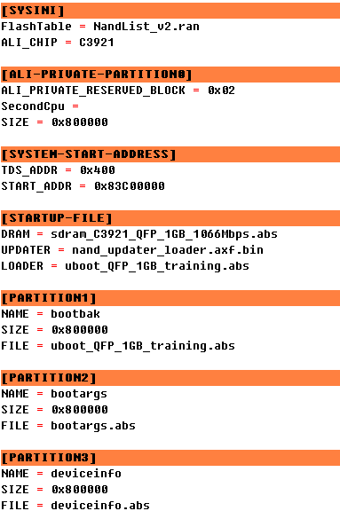

Figure . Partition Information



# Flash Burning

## Connecting to Platform

1. Prepare a USB cable and an adapter as shown below.

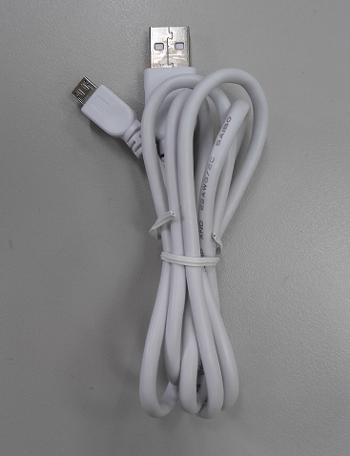 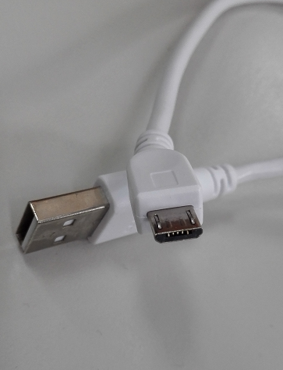

Figure . Sample Cable and Adapter

1. Connect the platform (shown in Figure 3) to a PC using the USB cable, as shown in Figure 4. Press and hold the “Burn NAND” button, and connect platform to PC via USB cable.

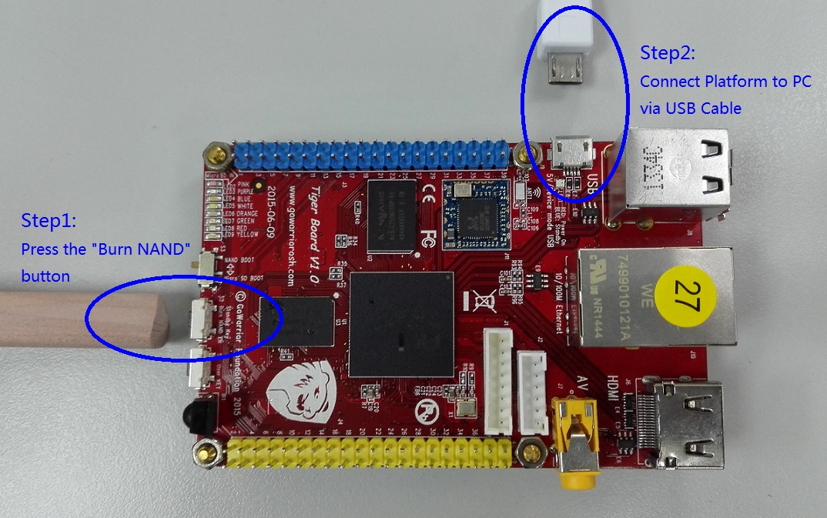

Figure . Sample Demo Board

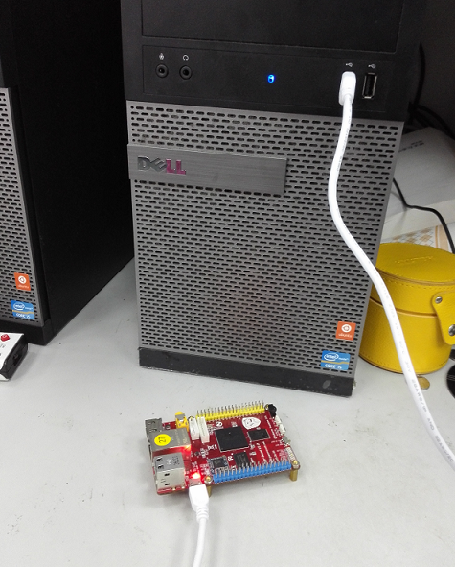

Figure . Connect Platform to PC via USB Cable

1. Run FTool.exe.

If the following screen appears, it indicates successful connection. If not, please try again.

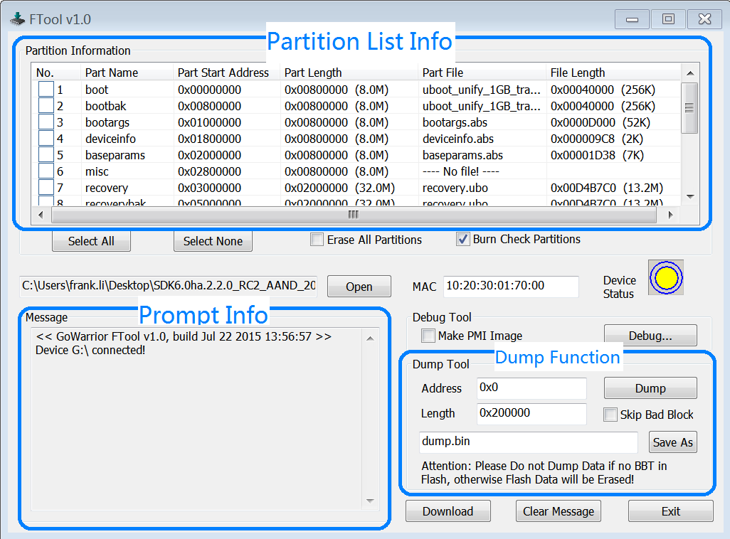

Figure . Connect to Platform

## Opening Profile

When FTool is opened, the profile ALI.ini in the current directory will be parsed automatically. Other profiles can also be opened.

Please pay attention to the size of partition list in ALI.ini. The partition size should be greater than the size of burned file.

[PARTITION1]

NAME = bootbak

SIZE = 0x800000

FILE = uboot_unify_1GB_training.abs

The TOTAL-SIZE of partition should be less than the capacity of NAND Flash.

For example, the capacity of NAND Flash selected should be greater than 0x24400000 bytes, or the partition list in ALI.ini needs to be reconfigured.

[PARTITION-COUNT]

COUNT = 9

TOTAL-SIZE = 0x24400000

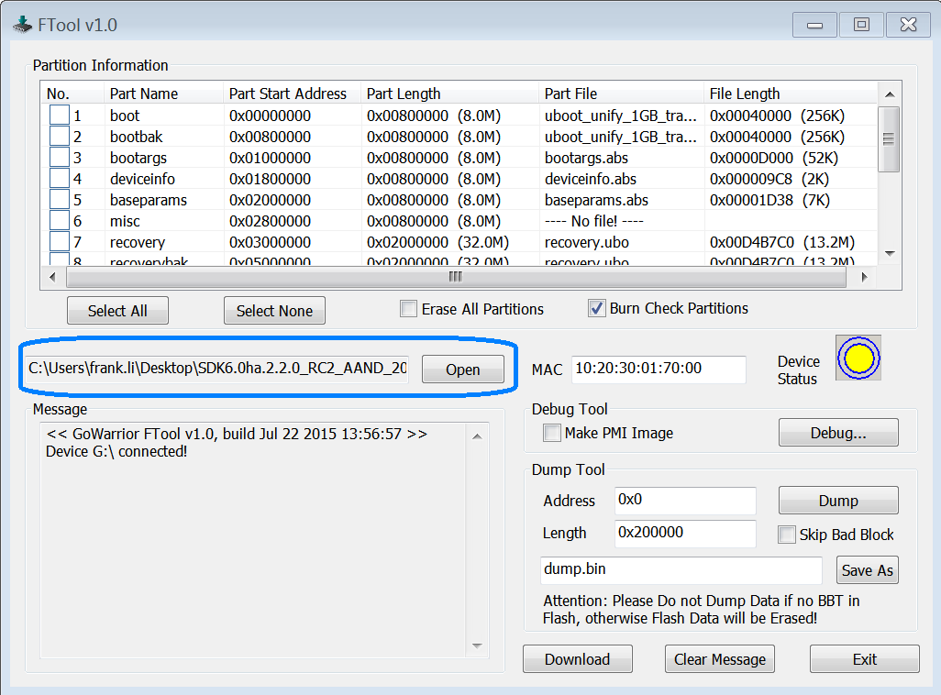

Figure . Open Profile

## Selecting Partitions to Burn

You can either choose Select All to burn the whole Flash or choose Select None to cancel all the partitions selected.

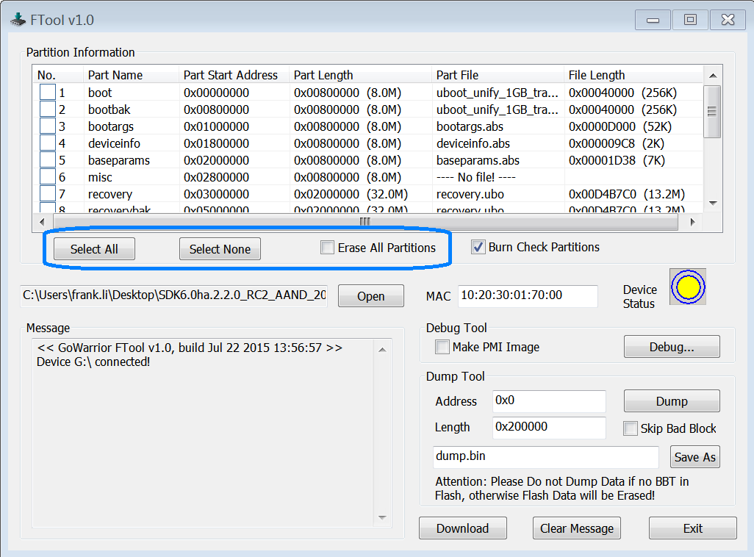

Figure . Partition Options

You can also select one or more partitions to burn, or check Erase All Partitions to erase the whole Flash.

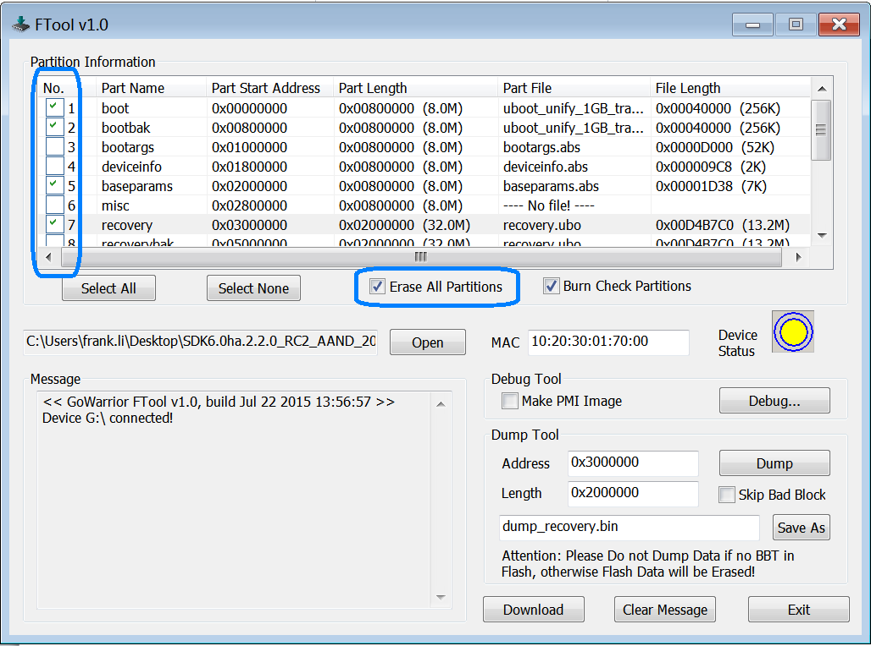

Figure . Select Partitions to Burn

## Starting Burning

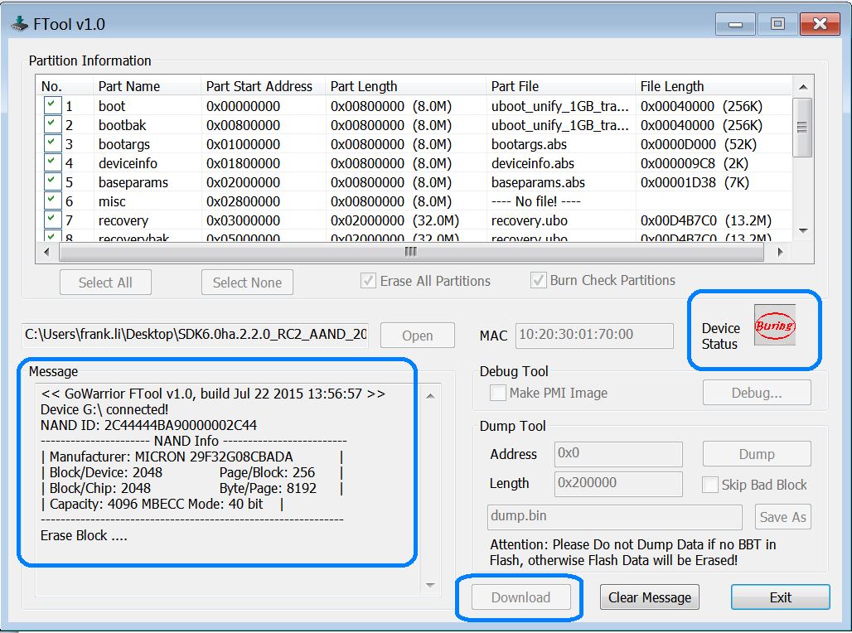

Figure . Start Burning Flash

## Finishing Burning

When the following screen appears, it indicates successful burning.

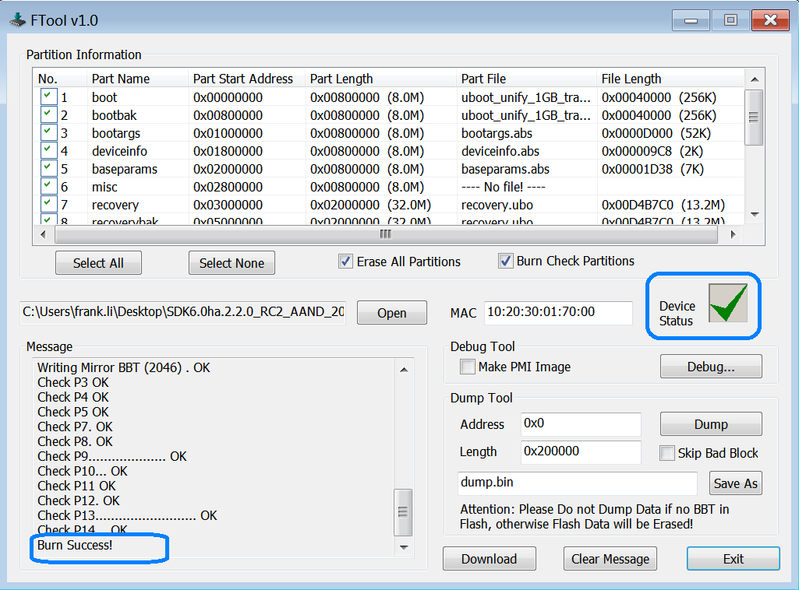

Figure . Burning Completed



# Making A Burning File Package

FTool supports burning the single file in ZIP archive format.

There are two methods to make the burning file package.

1. Use Linux zip command

Put the files (exclusive of files related to FTool) to be zipped in the same directory, and execute the following command.

user@shsa02:~/work/SDK6.0ha.1.1_ACAS1.1_20140507$ zip -0 ALi.abp *

1. Use Windows zip utility for file compression (WinZIP/WinRAR).

Figure 12 illustrates the options that need to be configured for making a zip package. Please pay attention to the items circled in blue. The files will be packetized to produce ALi.abp file.

***C:\Users\Icy.Liu\Pictures\icons\note.pngNote:***

When the second method is adopted, if some files in the storage package need to be updated, do not drag the files to the compression tool interface directly .The proper way to do this is to unzip the storage package to some directory, use the new files to overwrite the original files, and recompress the files to generate a new storage package by making configurations indicated in Figure 12.

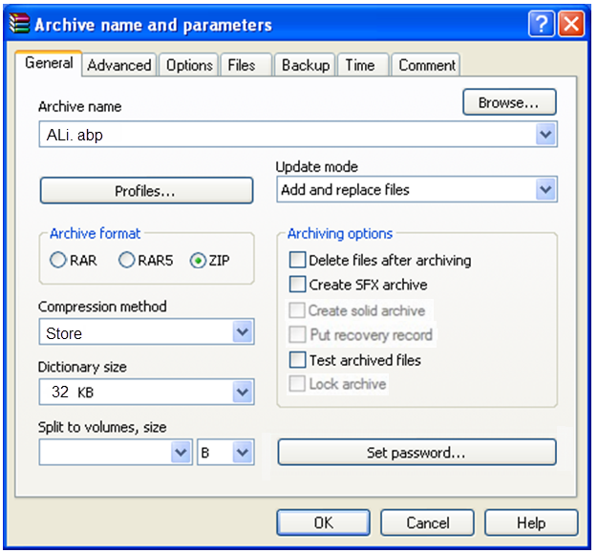

Figure . Archive Name and Parameters

# C:\Users\kenny.guan\Desktop\ALiTechSupportingDocumentTemplate\封面.pngFlash Dumping

## Connecting to Platform

It is the same with that in 2.1 Connecting to Platform.

## Opening Profile

It is the same with that 2.2 Opening Profile.

Generally, the opened profile should match the partition list in the platform. Otherwise, the data dumped by partition may be incorrect.

## Selecting Items to Dump

* Dump a partition

Select a partition in the partition list, and the address and length of this partition will be automatically calculated in the Dump Tool Column..

* Dump a partition segment

If you need to dump the entire NAND Flash or dump the specified data address and length, please enter the address and length in the Address and Length fields of the Dump Tool area.

Dumping does not skip the bad blocks by default. If you wish to skip the bad blocks, please select **Skip Bad Block**.

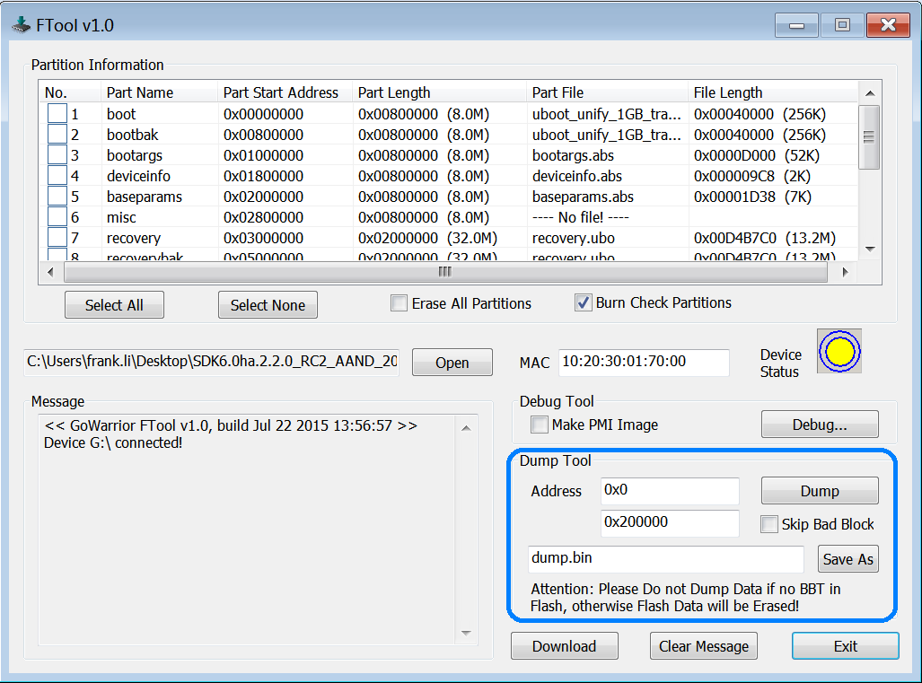

Figure . Select Items to Dump

## Starting Dumping

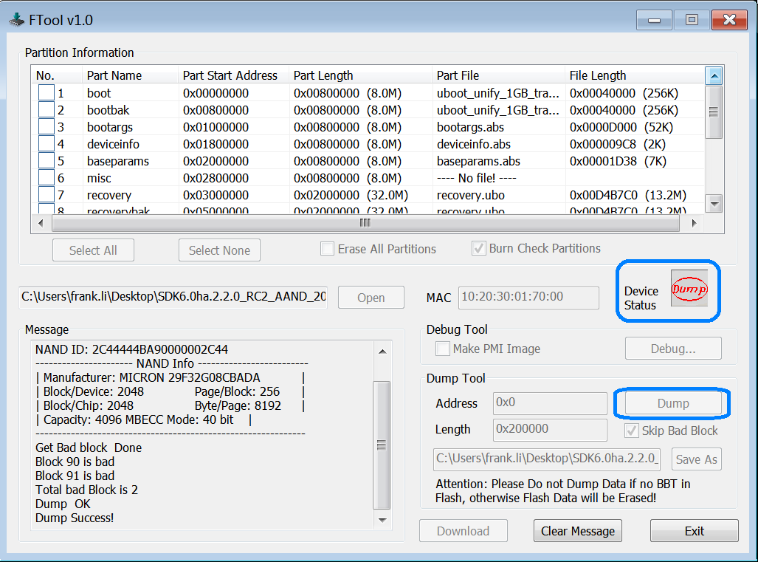

Figure . Start Dumping

## Finishing Dumping

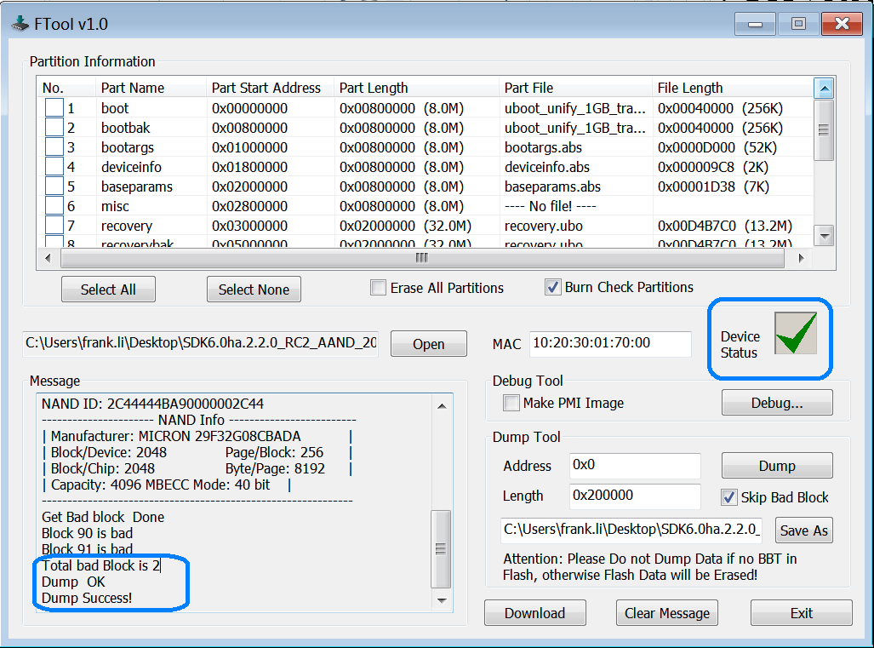

Figure . Dumping Completed

# C:\Users\kenny.guan\Desktop\ALiTechSupportingDocumentTemplate\封面.pngModifying MAC Address of Platform

## Connecting to Platform

It is the same with that in 2.1 Connecting to Platform.

## Opening Profile

It is the same with that 2.2 Opening Profile.

## Modifying MAC Address

If a burn file contains the deviceinfo file, FTool will automatically resolve MAC address from the deviceinfo file and display it on the screen, as shown in Figure 16. You can edit the MAC address by clicking on MAC edit box.

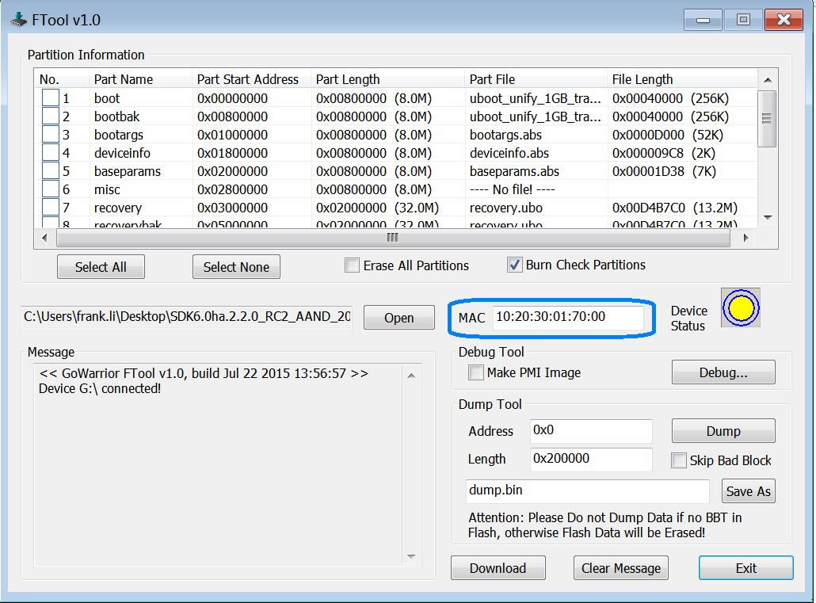

Figure . Edit MAC Address

C:\Users\Icy.Liu\Pictures\icons\note.pngNote:

FTool will automatically detect whether MAC address needs to be modified. During burning, FTool will compare the MAC address info in the edit box of the screen with that saved in the deviceinfo partition. Once the address difference is detected, it will automatically tick the deviceinfo partition and burn MAC.



# Partition Burn Check

Upon completion of partition burning, FTool will read back the partition data from Nand Flash and compare it with the original data to ensure successful burning. As this process takes a relatively long time, the Burn Check partitions option on the interface is provided to support reading back or not reading back data for confirmation.

FTool defaults to check Burn Check Partitions. If you wish to cancel the data confirmation process, you only need to uncheck Burn Check Partitions.

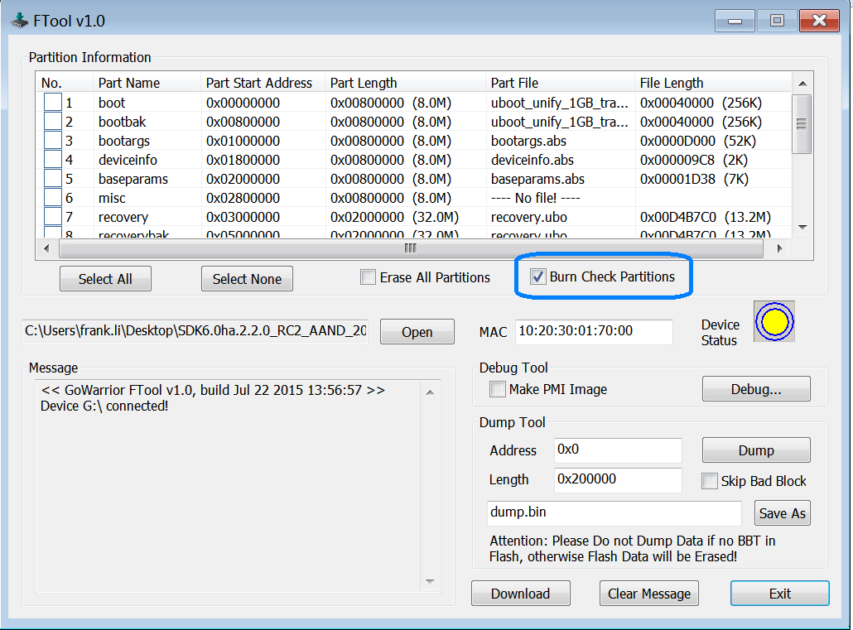

Figure . Partition Burn Check

Revision History

| Date | Revision | Changes |
| --- | --- | --- |
| May 15, 2015 | v2.9 | Added detailed description about how to connect a platform to PC in 2.1 Connecting to Platform. |
| Feb. 3, 2015 | v2.9 | Replaced FTool screenshots throughout this manual. |
| Jan. 8, 2015 | v2.5 | Initial release |

Table . Revision History



**www.alitech.com**



**USA Office**

Tel: +1-480-882 8639

Fax: +1-480-491 0202

**Europe Office**

Tel: +41-22-816-1900

Fax: +41-22-816-1949

**Korea Office**

Tel: +82-2-2043-3601

Fax: +82-2-2043-3602

**Shenzhen Office**

Tel: +86-755-2519-5788

Fax: +86-755-2519-5393

**Headquarters**

Tel: +886-2-8752-2000

Fax: +886-2-8751-1001